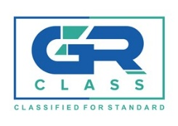
ISM CODE
ISM-PR-01 | PROCEDURE FOR COMPLIANCE VERIFICATION

PROCEDURE FOR COMPLIANCE VERIFICATION

  - This procedure defines the requirements for auditing Safety Management Systems and issuing SMC and DOC.
  - The procedures to follow for verification of compliance with the ISM Code must be in accordance with all statutory documents related to the Code issued by the IMO, as well as applicable flag state directives, and industry practices.
  - All documents and records relevant to the Safety Management System must be available for revision during audits. Records must date to at least three (3) months before the audit. These records must show the internal audit records of the company and on board of each vessel, along with all the associated non-conformities and closure of such.
  - Audited companies and ships must provide detailed arrangements to ensure that they comply with the Code’s requirements. Companies must provide objective evidence to auditors, showing that all of the Code’s requirements have been implemented.
  - In addition to SMS records, the Company must have available all certificates and classification records. The authenticity of these documents may be verified during or after the audit.

